Proof of Pappus’ Theorem with Circle Inversion  
by Developing an Open Source Software Application

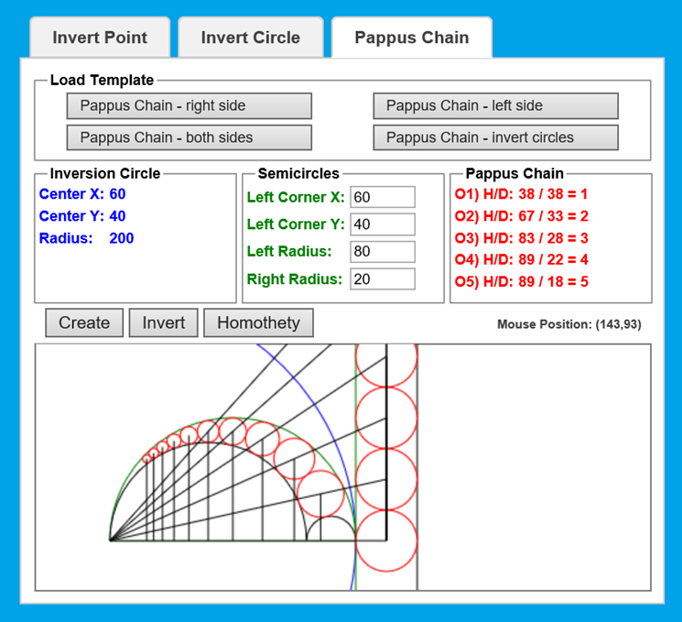

sukarablog.weebly.com